Lab Design and Implementation of User Module Using JSP

ID: Name:

1. **Objectives and Preparations**
   * + 1. **Objectives**

* To use HTML form
* To use 9 implicit objects
* To explore how and when to use request, session, and application to store and transfer data.
* To master the method of data verification on server-side
* To explore the principle and development process of Web application
* To design and implement User Module including Registration, Logining, and Resetting personal information etc.
  + - 1. **Preparations**
* HTML Form
* Syntax of JSP
* Implicit objects of JSP

1. **Requirements Analysis and Overall Design**

You can customize your user module or refer to Oracle’s user module. The website is

<https://profile.oracle.com/myprofile/account/create-account.jspx?source=:ow:o:h:nav:OHP0625ViewAccountsButton>.

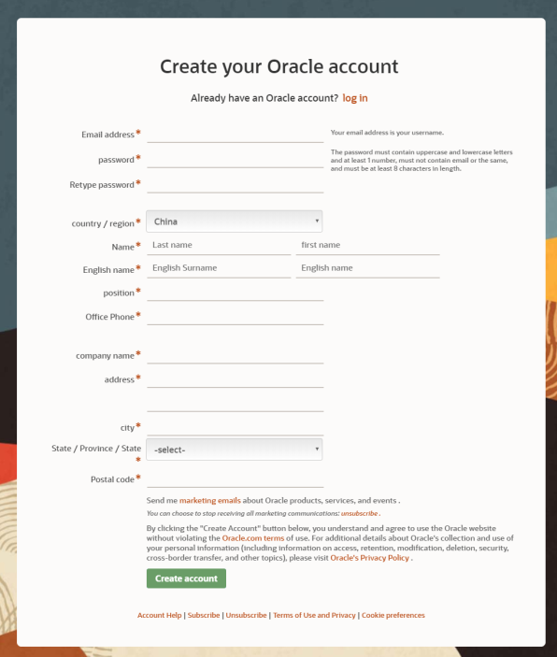

1) Registration, 2) Logining, and 3) Resetting personal information are required in your user module. Other functionalities are also permitted.

1. **Design Interface**

Post your Renderings.

1. **Design Database**

You can use collections such as Map, List, or Set to Store your data, instead of DBMS.

1. **Codding and Debugging**
2. Post your codeincluding class diagram, JSP code, relations among Web pages, etc.
3. Post your questions and the corresponding solutions
4. **Results and Summary**